Chapter 4 Design and Methodology
This chapter establishes how the system is put together and why it is put together that way. It describes the development process actually followed, the architecture component by component, the two pipelines at the system’s core — machine learning and retrieval-augmented generation — the workflow and its decision points, the data model, and the interface principles. It then sets out the alternative designs that were considered and rejected, in each case naming the evidence that decided it, and closes with the dataset and the preprocessing that produced the knowledge base. Throughout, the design is described as built; where the delivered design differs from the one proposed in P1/P2, the difference is stated and its evidence given.

4.1 Design Process and Methodology Overview
The project followed a phase-structured variant of the Software Development Life Cycle in which each phase is bounded by two documents rather than one: an architecture specification written and frozen before implementation, and a validation record written after it. Twenty-three numbered phases were executed in this form, from the retrieval validation gate through to the final interface work.

4.1.1 Freeze-then-build
The freeze step is the load-bearing part of the method, and it operates at three levels.
- Architecture is frozen before code. Each phase’s design document is completed, reviewed and marked frozen before implementation begins. Where implementation then revealed the document to be wrong, the correction was recorded as a correction — for example, a missing field on an entity found during Phase 4, or an ordering error in the Phase 12 workflow in which questionnaire and explainability were drawn as parallel siblings when one must precede generation and the other must follow it. Recording these as corrections rather than absorbing them keeps the document trustworthy.
- Code is frozen before measurement. A code freeze was committed on 2026-09-19, and the baseline it produced was tagged. Every change after it is therefore a deliberate, documented post-freeze amendment rather than drift, which is what allows Phase 22’s paired comparison to attribute a difference to the change under test rather than to accumulated edits.
- Criteria are frozen before results exist. Each evaluation phase pre-registered its primary endpoint, its statistical procedure and its decision rule in a committed document before any output existed to score. This is verifiable from commit order.
The discipline was applied symmetrically, which is the only thing that makes it worth anything. In Phase 21 the pre-registered primary endpoint did not clear, and the pre-registration forbade promoting any other metric in its place; that ban was honoured and the negative result is reported as the phase’s headline (§6.4). In Phase 23 the selection rule was applied mechanically by a script rather than by judgement, and it selected the incumbent (§6.6). In Phase 20 an entire evaluation tier was discarded for failing its own validity check (§6.3).

4.1.2 How pre-registration shaped the design itself
Pre-registration is usually discussed as an evaluation practice, but here it shaped the architecture directly, in three concrete ways.
- The evidence mode became a configuration value rather than a code path. Because Phase 21 needed to compare three evidence conditions, ContextBuilder takes its evidence mode injected from configuration. An ablation arm is therefore a restart with an environment override, not a branch in the source — which means the arms cannot drift apart, and the production arm is the same code that was measured.
- Thresholds became named, documented constants with a recorded provenance. Every behavioural threshold lives in one configuration module and carries, in the source, how it was chosen: pre-registered, calibrated, post-hoc revised, or a plain engineering default. The one threshold whose selection rule changed after a failure was observed is labelled post-hoc in capital letters in the source itself (§5.3).
- The prompt and the checker were made to share one word list. The temporal terms the prompt forbids and the terms the consistency checker matches on are the same configuration value. A prompt banning different words from the ones the checker looks for would make the measured rate a statement about two unrelated vocabularies rather than about the system.

4.2 Design Specification

4.2.1 System architecture
The system is three processes on one host: a Next.js frontend, a FastAPI backend, and Ollama serving the language model, with ChromaDB and SQLite as persistent stores and BiomedCLIP, EasyOCR and CheXbert loaded inside the backend process. Figure 4.1 shows every component and every connection between them.
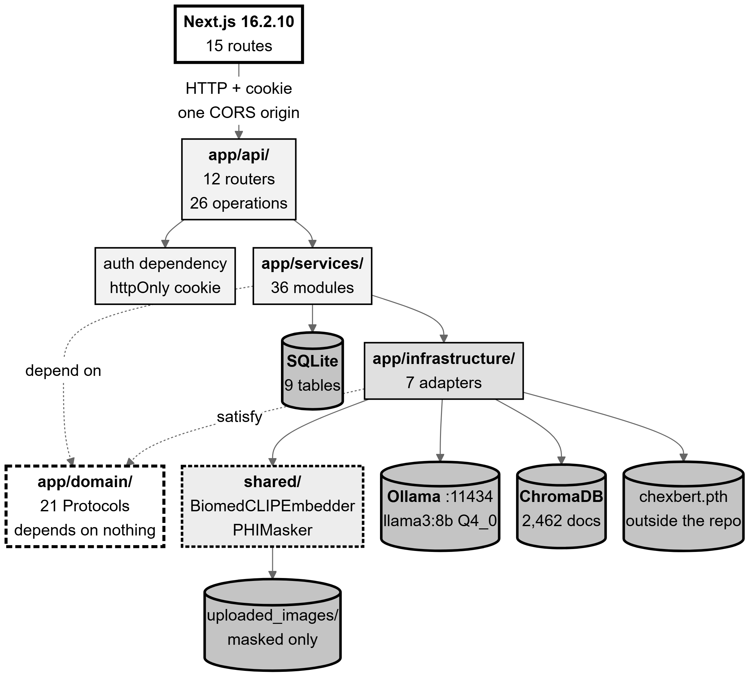
Figure 4.1: System architecture as implemented. Read it as four rings: the browser, the FastAPI process (API → services → domain ← infrastructure), the shared/ package, and the external processes and stores. The dashed arrows are the structural claim: services and infrastructure both point inward at the domain layer, which depends on nothing.
Source: thesis final report/03_diagrams/01_system_architecture.png, derived from backend/app/main.py:106-269, domain/interfaces.py, and live readings taken 2026-09-23.
The backend is organised in four layers with dependencies pointing inward only. The API layer holds FastAPI routers that validate a request, call one service, serialise the result and map an exception to an HTTP status — and contain no clinical logic. The services layer holds every rule, sequence and clinical decision. The domain layer holds entities and 21 runtime-checkable Protocol interfaces, and depends on nothing else in the codebase. The infrastructure layer holds adapters to the outside world, each satisfying exactly one Protocol. Persistence models are kept deliberately separate from domain entities: the two are not the same objects, so the database shape can change without the clinical logic changing with it.
Protocols rather than abstract base classes, and that choice is load-bearing twice. Because Python Protocols are satisfied structurally, the shared embedder in shared/ satisfies the backend’s embedder interface without importing anything from the backend — which is what keeps the research pipeline and the production application from importing each other while both use one embedder implementation. That matters more than it may appear: two independent BiomedCLIP implementations with a subtle preprocessing difference would not raise an error, they would silently degrade retrieval by placing knowledge-base vectors and query vectors in slightly different spaces. The second use is smaller but real: the prompt builder implements six of its interface’s seven methods and deliberately omits the seventh, because there is no translation pass to build a prompt for — Bengali is generated directly. A Protocol permits that; an abstract base class would not.
There is no dependency-injection framework. A single application lifespan constructs every shared collaborator once per process and attaches it to application state; routes read them from there and construct nothing expensive themselves. The model loads, the OCR engine, the labeller and — significantly — the modality gate’s text prompt vectors are all built exactly once. That last item is not an optimisation bolted on afterwards: the constructor line that encodes the prompt vectors is the cache the design requires.

4.2.2 The machine-learning pipeline
Figure 4.2 shows the machine-learning path end to end. Every number in it is the real configured value rather than an illustration.
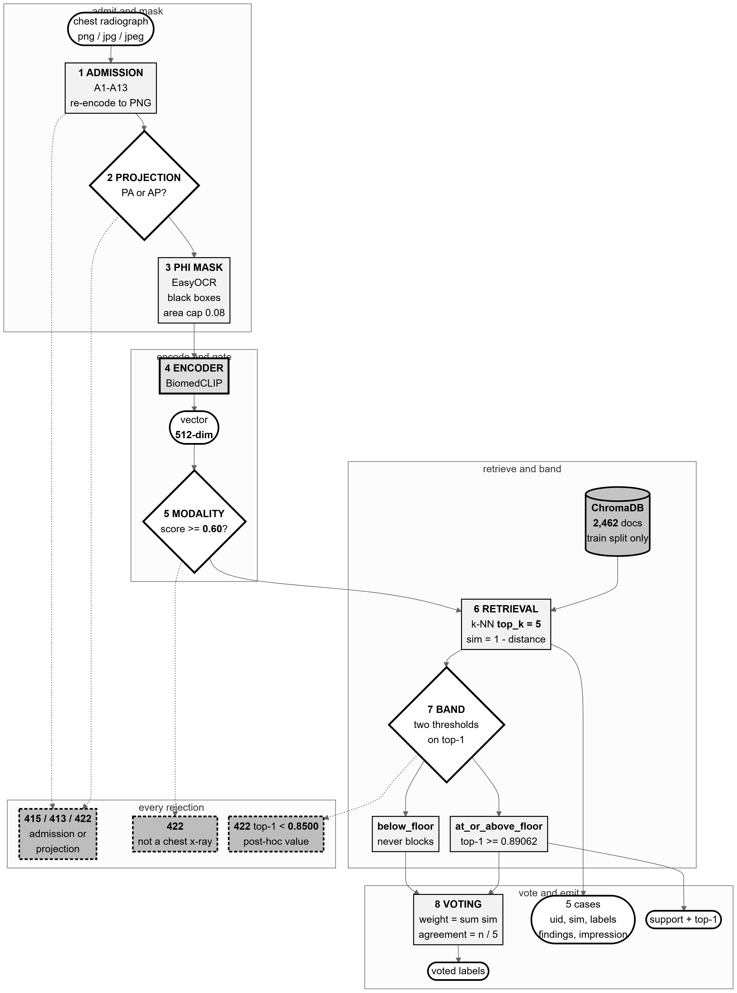
Figure 4.2: The machine-learning pipeline: upload → admission → PHI masking → BiomedCLIP encoding → modality gate → vector store → k-NN retrieval → label voting. White diamonds are decisions that really exist in the code; dashed edges are rejection paths. The projection threshold is marked in the figure itself as a post-hoc value.
Source: thesis final report/03_diagrams/02_ml_pipeline.png, derived from backend/app/api/retrieval.py:292-505, services/image_admission_service.py, modality_gate_service.py and core/config.py.
Preprocessing and admission. An uploaded file passes thirteen checks before anything expensive runs: an extension allow-list, a magic-byte signature sniff, agreement between signature and extension, size bounds, a verification pass followed by a second open for loading, a pixel ceiling, dimension bounds, and finally a re-encode from the pixel array alone. That last check is the strongest control in the sequence: whatever was uploaded, what proceeds is a PNG this process encoded, carrying no metadata, no trailing bytes and no embedded payload. The raw bytes never reach disk.
PHI masking, and the order it runs in. Detected text regions are masked with solid black boxes, and the masked file is written straight to its permanent location — one artefact, not two copies that could diverge. The ordering is a frozen decision: admit → mask → embed → gate → retrieve. Admission runs on the raw upload because an unsafe file must never reach the OCR library, and masking runs before embedding so that the vector the system judges and stores is derived from the pixels the system is willing to keep. Masking used to run last, from raw pixels; the reorder is safe because the embedding impact of masking was measured at a mean cosine similarity of 0.992 with none of 50 sampled images falling below threshold.
Encoding. The masked image is encoded by BiomedCLIP into a 512-dimensional vector, L2-normalised so that cosine similarity is a dot product for every downstream consumer. The encoder is frozen: no training of any kind occurs in this system.
The gate, and why there are two thresholds rather than one. The same vector is reused — never recomputed — for two distinct questions. First, is this a chest radiograph at all? A softmax over BiomedCLIP text prompts, using the model’s own learned logit scale as its temperature, must exceed 0.60; below that the upload is refused and the masked file is deleted. Second, after retrieval, how well supported is this image by the knowledge base? Here two thresholds apply to the top-1 similarity: below 0.8500 the upload is refused as a projection mismatch, while the retrieval floor at 0.8906208872795105 only classifies support as at_or_above_floor or below_floor and never blocks. Collapsing the two into one value would delete the middle band that the disclaimer, the stored support category and the evidence display all depend on. One property of this design is recorded honestly: the floor’s low-support branch was never exercised in calibration — 0 of 300 frontal cases fell below it.
Retrieval and label voting. The vector queries a ChromaDB collection of 2,462 documents built from the training split only, returning the five nearest neighbours with their real findings and impression text. A similarity-weighted vote over those neighbours’ curated labels produces, for each label, a weight and an agreement fraction. The agreement fraction is what the interface later displays, and it is explicitly not a probability that the report is correct — the interface says so at the point of display.
The system does not classify, and this is the central design commitment. No classifier is trained, and no predicted probability over a label set exists anywhere in the pipeline. The voted labels are a summary of what five real archived cases were labelled with, not a prediction about this patient. The consequence is traceability: every finding the draft asserts can be traced to specific retrieved studies that a reader can open and judge for themselves. A classifier would produce a number; retrieval produces evidence. Section 4.3 gives the empirical basis on which this was chosen over the classification design P2 proposed.

4.2.3 The retrieval-augmented generation pipeline
Figure 4.3 shows the generation path, and is organised around the three questions a reader should ask of any RAG system: what is retrieved, what reaches the model, and what is checked afterwards.
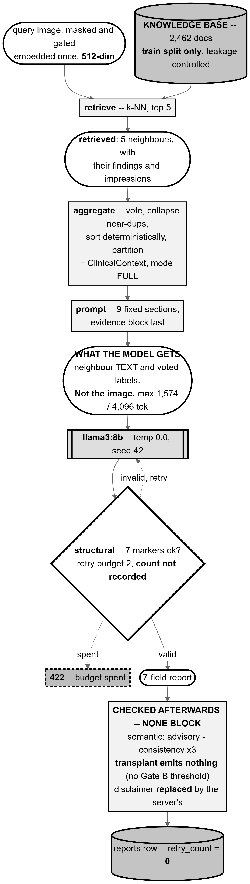
Figure 4.3: The retrieval-augmented generation pipeline. The node marked what the model gets is the one that matters most: the prompt carries the five neighbours’ findings and impression text plus the voted labels, and the image itself never reaches the language model.
Source: thesis final report/03_diagrams/03_rag_pipeline.png, derived from services/report_generation_service.py:160-355, context_builder.py, prompt_builder.py:168-206 and report_consistency_service.py.
What is retrieved. Five neighbour studies from a collection that is the training split only, leakage-controlled twice over: at study level, so a study’s own second view cannot be its own neighbour, and by near-duplicate clustering, so a study’s near-identical twin cannot sit on the other side of the split. A query case can therefore retrieve neither itself nor its own near-duplicate.
How evidence is aggregated. The context builder sorts the retrieved cases by descending similarity with a deterministic tie-break, collapses near-duplicates, and partitions the evidence per label. It performs no diagnosis and no synthesis — it organises, and nothing more. This is a deliberate boundary: any judgement it made would be a clinical judgement made by a component with no way to explain itself.
What reaches the prompt. Nine sections in a fixed order, carrying the retrieved reports’ text, the voted labels with their agreement, the questionnaire answers, the clinical notes and the language instruction. Two properties are worth stating explicitly. The image contributes only the 512-dimensional vector that selected the neighbours; generation is text-only. And the prompt fits comfortably: measured across all 477 cases, it peaks at 1,574 tokens of a 4,096-token window, so the evidence block is never truncated — a failure mode that would silently drop evidence and would not be visible in the output.
What is checked afterwards — and the honest answer is: nothing that blocks. This is stated plainly because it is the single most misreadable property of the design.
Table 4.1: The post-generation checks, and which of them can stop a report.
Source: 03_diagrams/03_rag_pipeline_caption.md; services/response_validator.py:6-10; main.py:233-241.
Check | What it does | Can it stop a report?
Structural validation (7 markers) | Parses the seven delimiter-marked fields. | Yes — the only one. Two content retries, then HTTP 422.
Semantic validation | Warns on empty sections, unsupported terms, an unreflected top label. | No — advisory by design. It produces warnings and gates nothing.
Temporal check | Detects comparison language where no prior study exists. | No — observational.
Transplant check | Scores overlap between the impression and each neighbour’s impression. | No — and it currently emits nothing at all: no threshold has been calibrated.
Contradiction check | Labels findings and impression separately and compares them. | No — observational.
Disclaimer | Not a check: the server replaces the model’s disclaimer text. | n/a
That the semantic validator is advisory is a deliberate decision rather than an omission. A validator that blocks must be right; one that advises may be conservative. This validator flags terms absent from the retrieved evidence, and a correct report can legitimately use a term its neighbours did not — so blocking on it would refuse good reports. The consequence, stated plainly, is that the only automated gate on clinical content is structural, and everything clinical rests on the doctor’s review. Section 6.7 discusses whether the evidence supports that choice.

4.2.4 Workflow and decision points
Figure 4.4 traces the whole flow from upload to a persisted draft, with every decision node in it being a branch that really exists in the code. The figure’s task is as much to show what does not branch as what does.
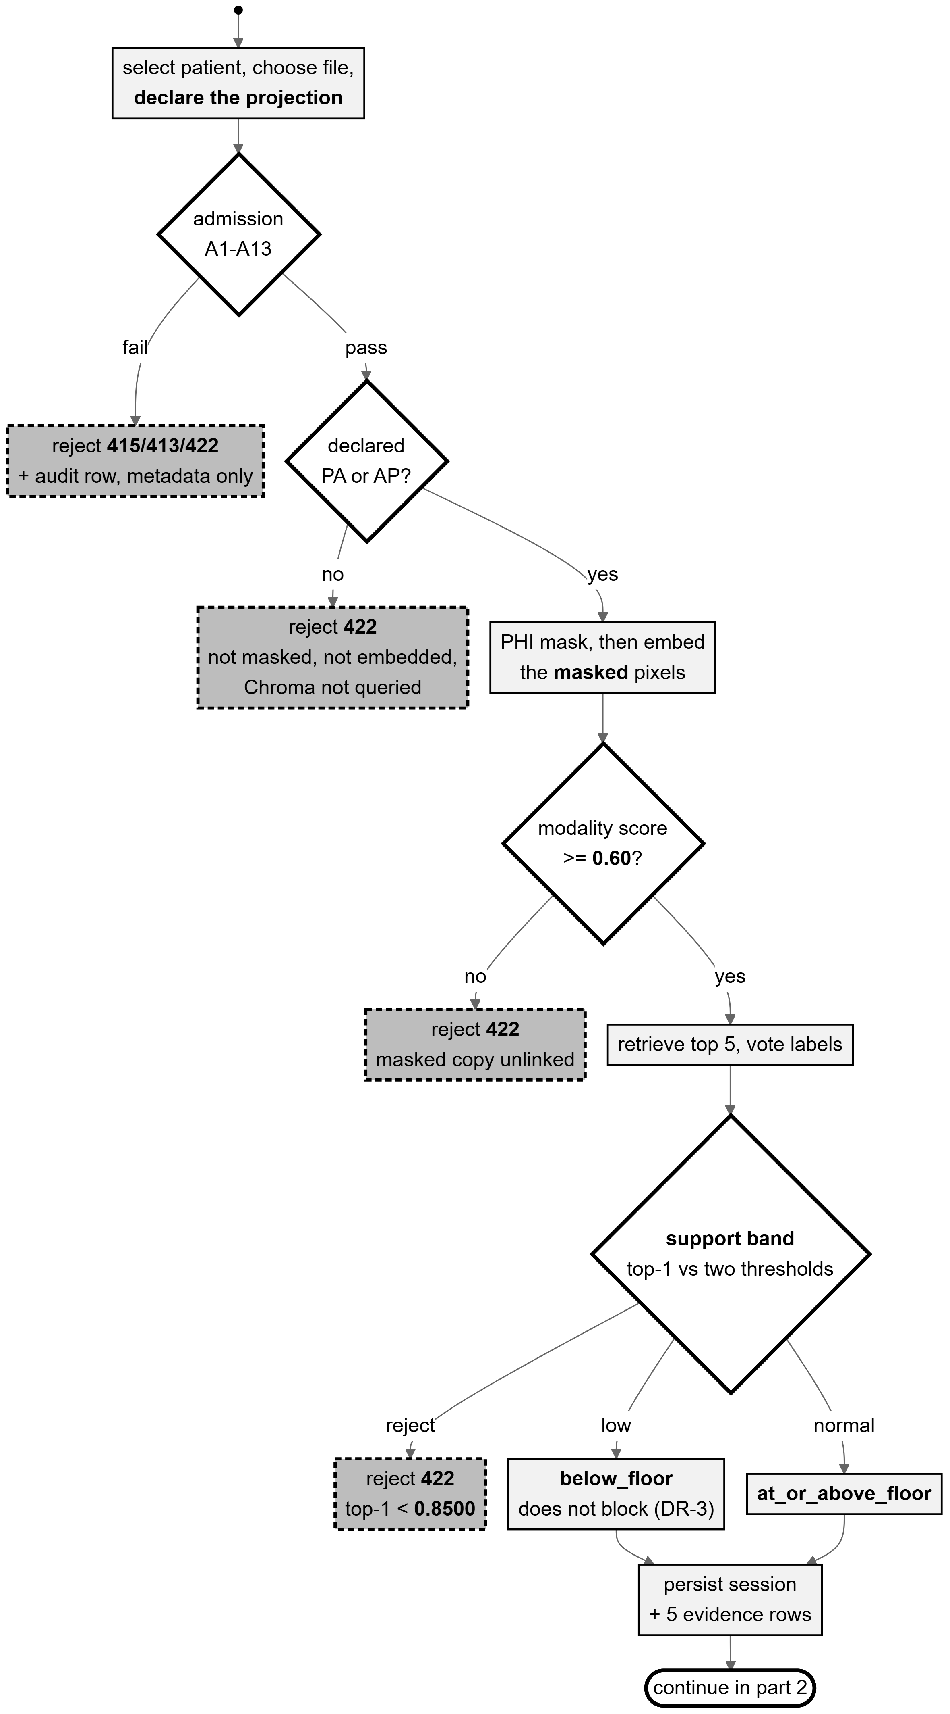
Figure 4.4: Activity flow, part 1: upload → admission → masking → embedding → modality gate → retrieval → support band → persistence. Dashed mid-grey nodes are rejection paths; each corresponds to a specific HTTP status.
Source: thesis final report/03_diagrams/05_activity_report_generation.png, derived from backend/app/api/retrieval.py:292-505.
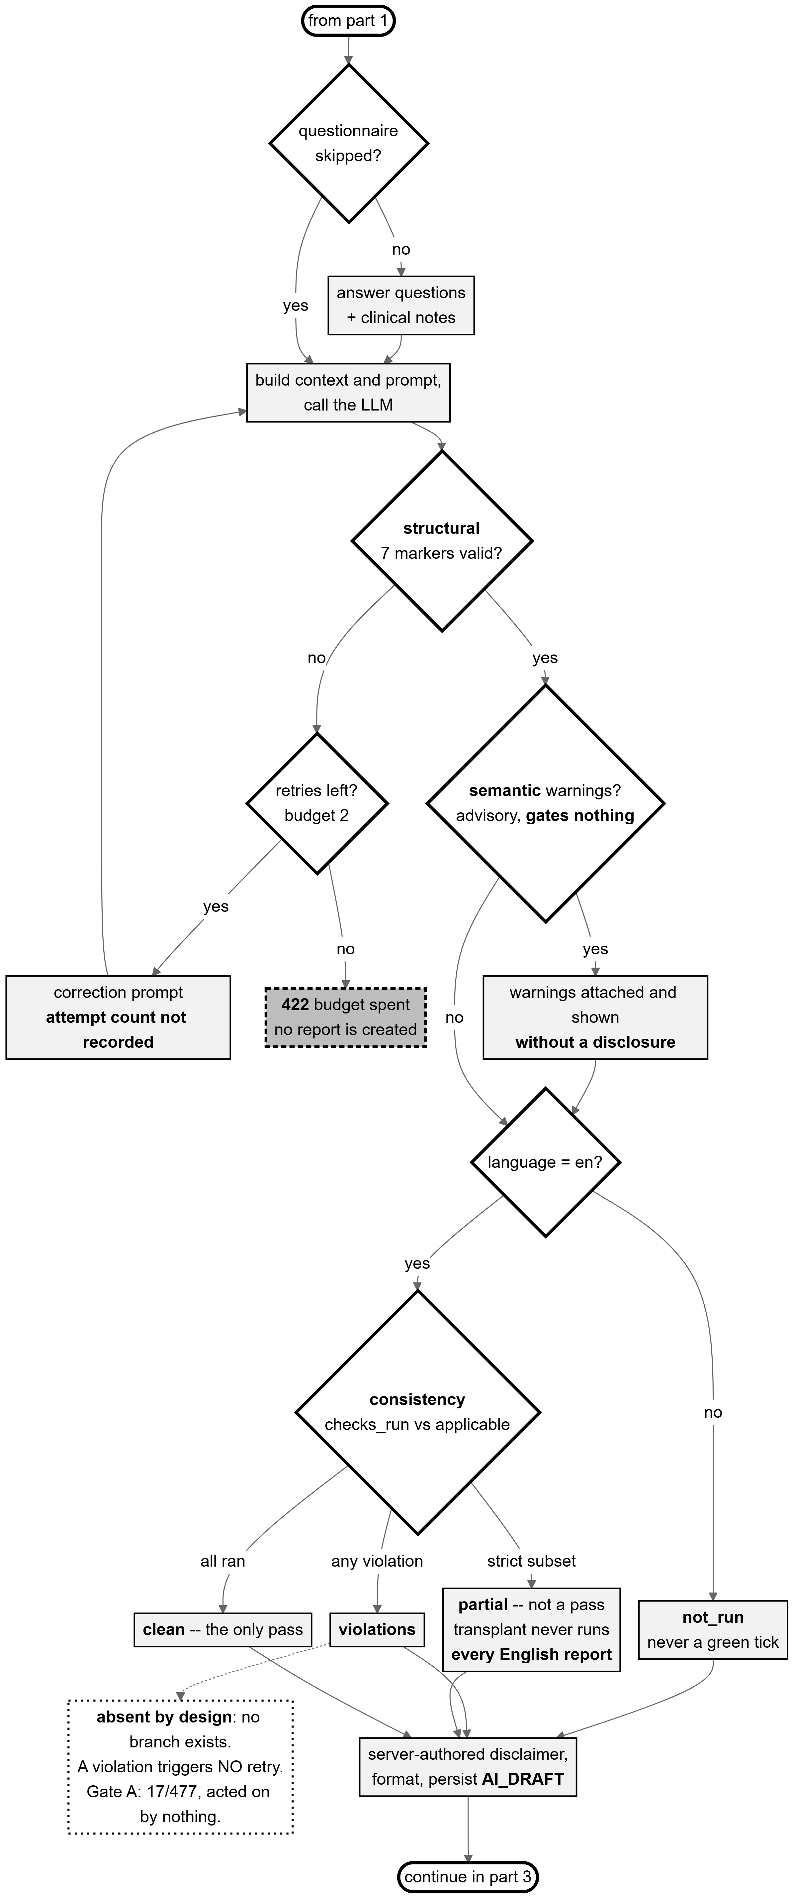
Figure 4.5: Activity flow, part 2: questionnaire → prompt → LLM → structural retry → semantic validation → consistency → persist as AI draft. The dashed box hanging off the violations state records a decision that does not exist: a recorded violation triggers no retry. Drawing it as an absence rather than a live branch is the point.
Source: thesis final report/03_diagrams/05b_activity_generation_review.png, derived from services/report_generation_service.py:139-355 and llm_orchestrator.py:56-110.
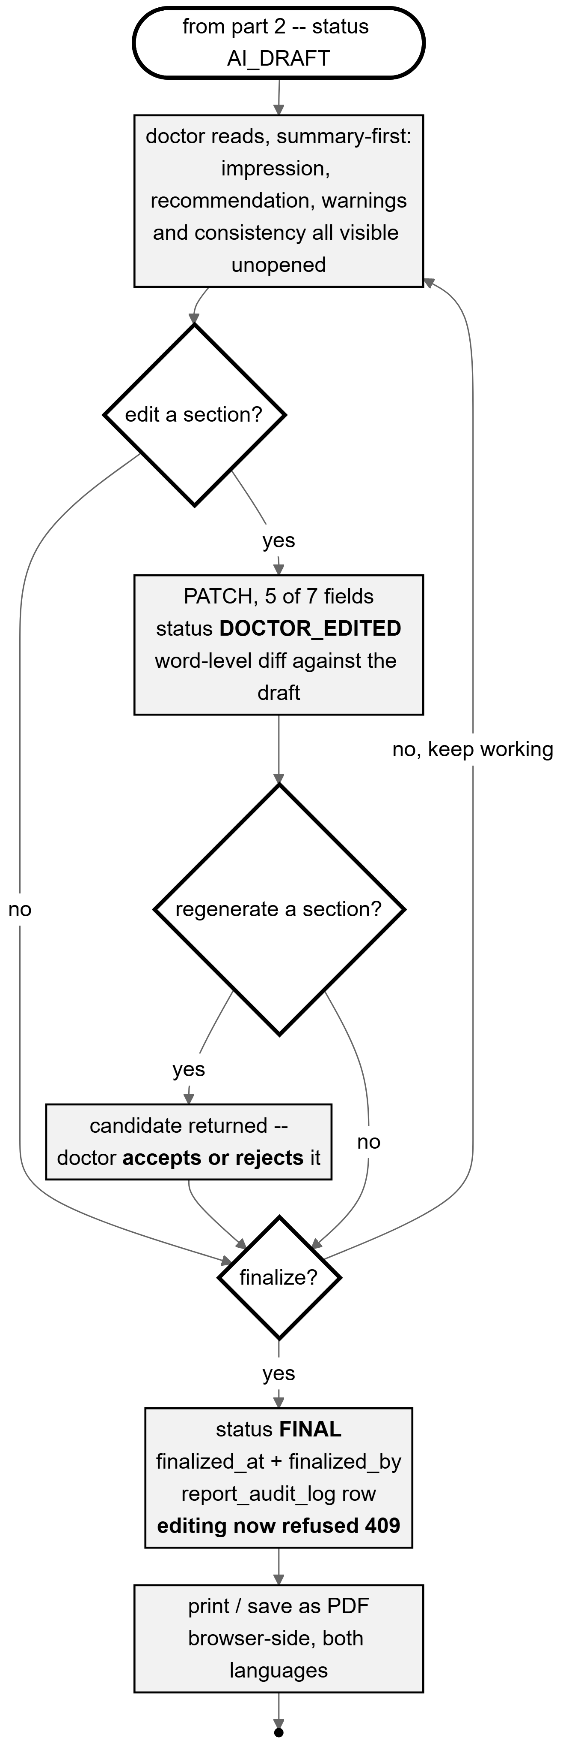
Figure 4.6: Activity flow, part 3: the doctor’s loop — read, edit, regenerate, finalize, print. FINAL is a one-way door: after finalizing, an edit is refused with HTTP 409, ownership or not.
Source: thesis final report/03_diagrams/05c_activity_doctor_review.png, derived from services/report_edit_service.py and api/reports.py.
Table 4.2: Every decision point in the flow, and whether it blocks.
Source: 03_diagrams/05_activity_report_generation_caption.md, with the file and line of each branch.
Decision | Blocks? | Outcome
Admission checks A1–A13 | Yes | HTTP 415, 413 or 422; an audit row is written.
Declared projection A14–A17 | Yes | HTTP 422. A lateral declaration is refused before masking, embedding or any query.
Modality gate, score ≥ 0.60 | Yes | HTTP 422; the masked image is unlinked.
Projection band, top-1 ≥ 0.8500 | Yes | HTTP 422 with reason FRONTAL_MISMATCH; masked image unlinked; the audit row carries the modality score.
Retrieval support vs the floor | No | Sets a category only, which reaches the disclaimer and the evidence display.
Structural validation, 7 markers | Yes | Up to 2 content retries with a correction prompt, then HTTP 422 carrying the last response and errors.
Semantic warnings | No | Advisory; stored and displayed.
Consistency state (4 states) | No | Observational; stored and displayed.
Doctor edit / regenerate / finalize | — | The human decisions. These are the only ones that change the report’s authorship.
Two consistency states must be read carefully, and the design makes that unavoidable. partial is not a pass: because the transplant check has no calibrated threshold it can never be listed as having run, so the set of checks that ran is always a strict subset of those applicable, and every English report lands in partial. And a non-English report shows not_run rather than nothing at all, because showing nothing is read by a clinician as “nothing wrong”, which would convert an acknowledged coverage gap into an affirmative false assurance.

4.2.5 Sequence of one generation
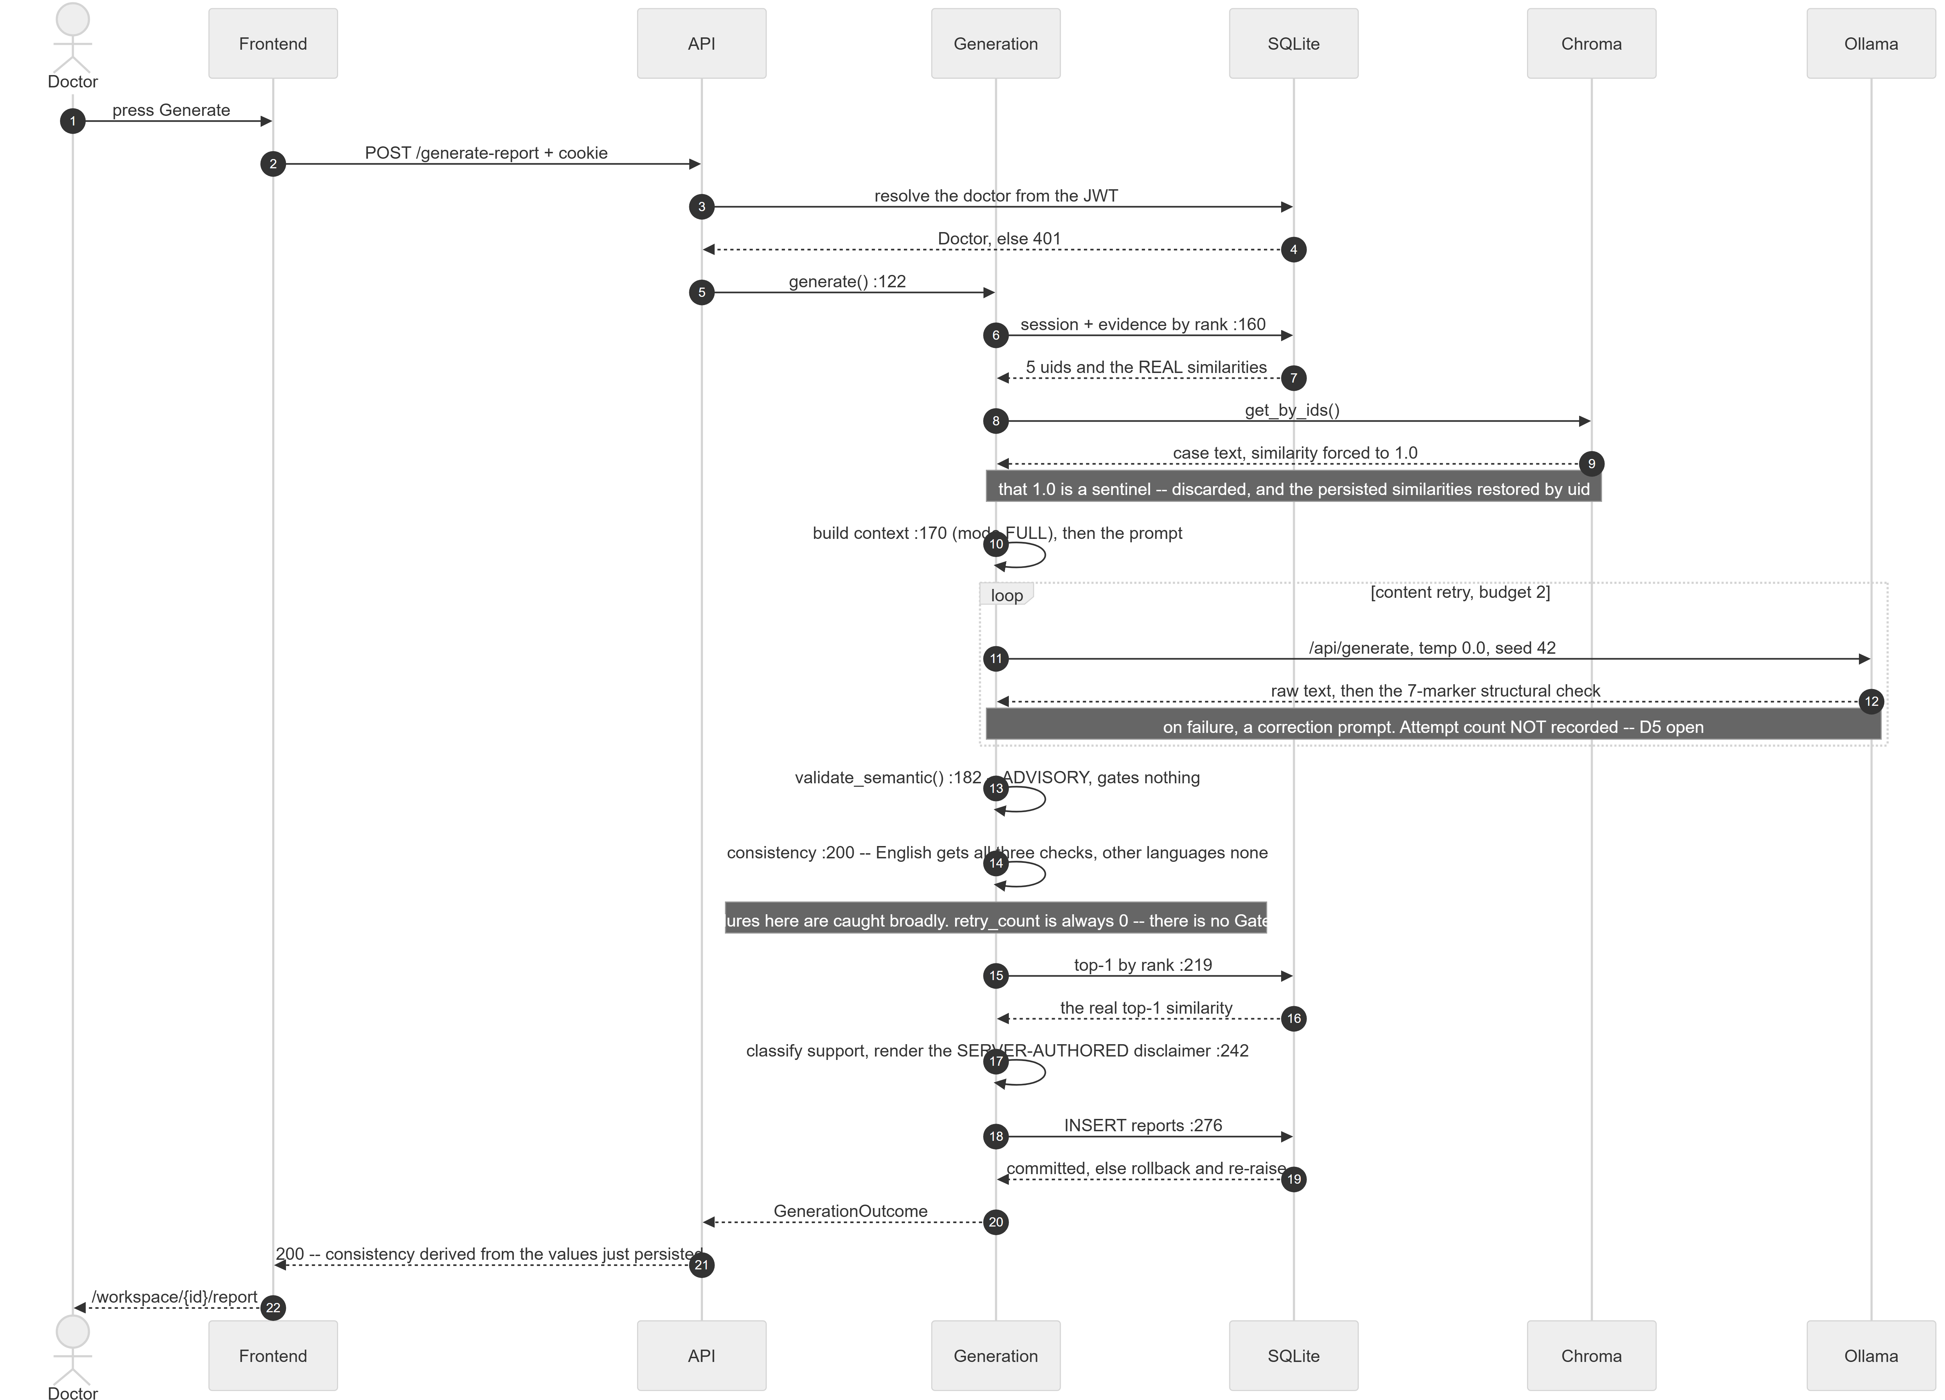
Figure 4.7: Sequence of a single report generation across seven participants. The numbers after a call are the line at which control passes on.
Source: thesis final report/03_diagrams/06_sequence_generate_report.png, derived from api/generation.py:94-151 and services/report_generation_service.py:139-355 at commit 99f3eab8.
Four properties of this sequence are worth drawing out, because each encodes a design decision that is not obvious from the component list.
- The similarity is restored, not recomputed. Fetching the retrieved cases back from the vector store by identifier is an unranked lookup, so it reports a sentinel similarity of 1.0 for every case. Three consumers once treated that sentinel as a measurement: vote weights collapsed to a plain case count, the evidence sort degenerated to alphabetical order, and the interface showed 100% on every case. The real values were never lost — they are persisted at retrieval time — and are restored keyed by identifier rather than zipped positionally, because the lookup can return fewer rows than were asked for.
- The retry loop exists, and what it does not record is stated. Up to two content retries, each with a correction prompt carrying the rejected text and the exact errors. The attempt count is never persisted. Every “zero structural failures” in Chapter 6 therefore means zero failed after retries, never zero needed a retry.
- The consistency check cannot fail the generation. Its exception handler is deliberately broad and its worst case is three NULL columns and a log line. The reasoning is explicit: a safety warning that can take down report generation is a net loss, because the doctor then loses the report entirely instead of receiving one with an unchecked caveat.
- The response cannot disagree with the database. The consistency block returned by the generation call is derived from the values just persisted, not from the in-memory result they were built from — so that call and a later read of the same report cannot describe it differently.

4.2.6 Data model
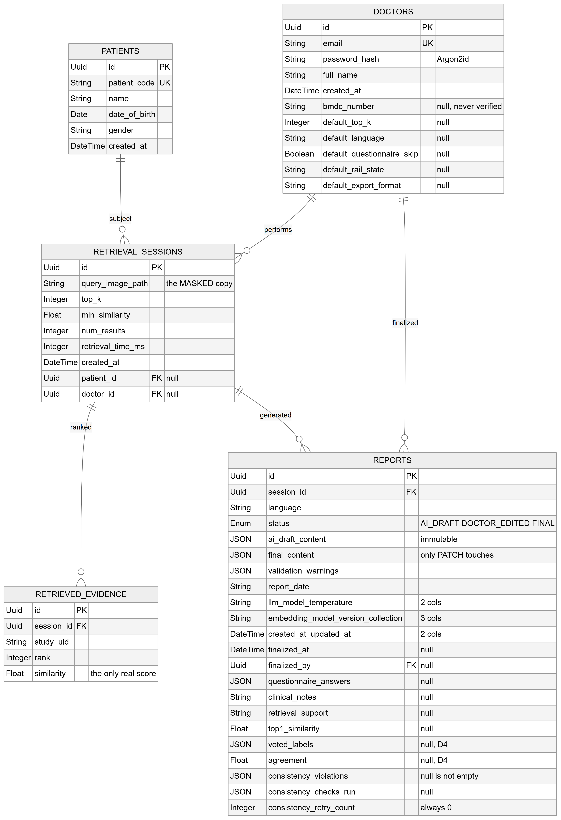
Figure 4.8: Entity relationships, part 1: the report lifecycle core — doctors, patients, retrieval sessions, retrieved evidence and reports.
Source: thesis final report/03_diagrams/07_er_diagram.png, derived from backend/app/models/*.py after alembic head 7f2a91c4d6e8.
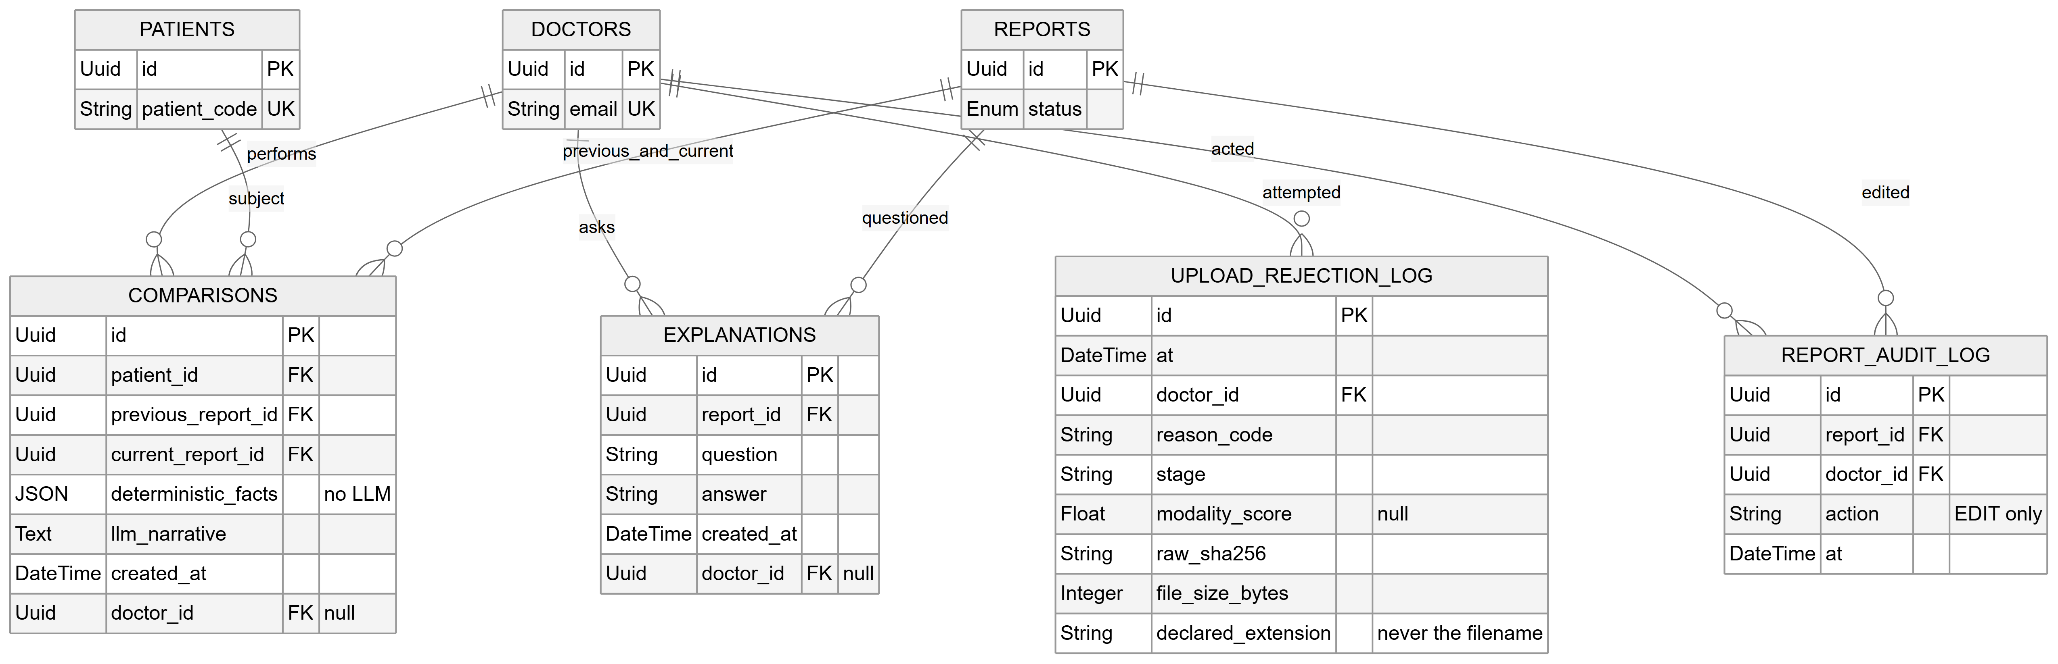
Figure 4.9: Entity relationships, part 2: the four satellite tables — comparisons, explanations, the report audit log and the upload rejection log. The three core tables are repeated with key columns only, as join anchors.
Source: thesis final report/03_diagrams/07b_er_diagram_satellites.png, same derivation as Figure 4.8.
Nine tables, reached through fifteen linear migrations. Three properties of the schema encode design decisions rather than mere structure.
- retrieved_evidence.similarity is the only place the real ranked similarity survives. It is not a cache of something re-derivable — it is the measurement, for the reason given in §4.2.5.
- NULL and the empty list mean different things, and the migration made the consistency columns nullable specifically to preserve that distinction. An empty violations list means checked and clean; NULL with an empty checks-run list means we know zero checks were applicable, which is the state a Bengali report is in; NULL on both means the checker raised and nothing is known. Writing an empty list for a Bengali report would assert it had been examined and found clean — exactly the false assurance the design forbids.
- doctor_id is nullable on every work table, because each of those columns was added by a later migration to a table that already held rows and no backfill was performed. This is why the ownership check treats a NULL owner as owned by nobody, editable by nobody rather than as an error.
Why two stores rather than one. SQLite holds the relational records; ChromaDB holds the vectors. The two answer different questions and have different lifecycles. The vector store is a rebuildable derived artefact — it was built once from the embedding cache in 1.03 seconds and can be rebuilt from the same inputs at any time — whereas the clinical records are the system’s durable state and must survive any re-indexing. Keeping them apart means the knowledge base can be replaced, re-embedded or extended without touching a patient record. It also keeps the specialised index in the tool built for it: approximate nearest-neighbour search over 512-dimensional vectors is what ChromaDB does, and the relational store is not asked to do it.
Why SQLite rather than the MongoDB proposed in P2. The data is unambiguously relational — a doctor owns sessions, a session yields evidence rows and a report, reports carry explanations, comparisons and audit rows, and ownership and foreign keys are enforced across those relations. A document store would have to reconstruct those joins in application code. SQLite additionally requires no server process, which matters directly for a design whose deployment claim is that a facility can run it on one machine. The cost is recorded rather than glossed: SQLite is single-writer and this deployment is single-process, so a multi-user installation would need a server-backed database, which is noted as a deployment decision deferred to later.

4.2.7 Interface design
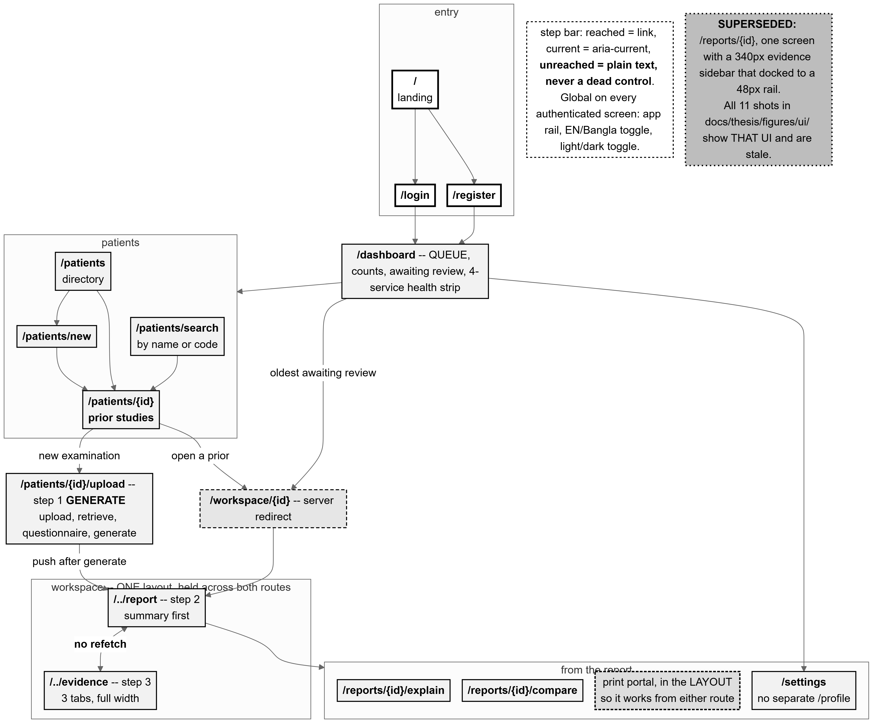
Figure 4.10: The page-based flow across all 15 frontend routes, with Generate → Report → Evidence at the centre. The dashed box records that the earlier single-screen workspace is superseded.
Source: thesis final report/03_diagrams/09_page_flow.png, derived from frontend/src/app/**/page.tsx and commit a8252e09.
The workspace was originally one screen doing three jobs: a film column, a report column and an evidence sidebar, competing for the same width. The evidence lost that competition twice, and was twice given more aggressive collapsing behaviour in response — treating a symptom. The screen was carrying more than one screen’s work, and it is now three routes: Generate, at the patient’s upload flow; Report; and Evidence, full width with three tabs.
Four design principles govern the interface, and each is enforced structurally rather than by convention.
- Evidence is visible, and reaching it costs nothing. The Evidence page fetches nothing at all: every value on it comes from the report object the segment layout already holds. Moving between Report and Evidence fires no request — not because a cache answers it, but because nothing asks again. A cache would satisfy this conditionally, correct until invalidated wrongly; hoisting the fetch into the layout satisfies it unconditionally, because the child routes have no loader to call.
- Warnings are never hidden. The impression, the recommendation, the validation block and the consistency verdict render outside the collapsible disclosure in every state, and four conditions force the disclosure open and disable its own control: a section being edited, a regeneration in flight or awaiting a decision, the finalize preview, and printing. A disclosure may cover context; it may never cover a conclusion or an alert. The invariant is asserted by test, because layout invariants rot quietly.
- An unchecked state never looks like a pass. The four consistency states are rendered by four separate components, deliberately not by one component parameterised by a colour lookup — because the parameterised version is the one in which a later edit silently gives the not-run state the pass treatment. partial is styled with not_run, not with clean, because it is closer to the former in what it licenses a reader to conclude.
- The human decides, and the printed document proves it. The printout is a second render built from the canonical seven-field list, not the screen re-styled by a print stylesheet — so a collapsed disclosure cannot produce a report that silently prints five sections short. The component takes no collapsed parameter and a test asserts its arity so that none can be added. The signature block prints only on a finalized report, because a draft is not a signed document.
Two further properties were verified rather than assumed. Bengali printing was proven by rasterising the page and looking at it, not by counting characters: a missing font subset produces empty boxes while leaving the text layer perfectly intact, so a character count would pass while the page was unreadable. The measured result was 9 sections and 781 Bengali codepoints with conjuncts correct and no missing glyphs. And the no-refetch guarantee was proven twice — once by component test and once in a real browser, counting report requests during a Report → Evidence → Report round trip, which recorded zero.

4.3 Alternative Designs Considered and Rejected
Five significant alternatives were considered, and four of them were tested rather than merely reasoned about. This section states what each alternative was, how it was verified, and what decided it.

4.3.1 Classification (DenseNet121) versus retrieval
The P1/P2 proposal specified a DenseNet121 classifier as the core of the pipeline, with its predicted disease labels driving report assembly and one of its feature layers serving as the retrieval embedding. The delivered system contains no classifier.
How it was verified. Phase 0 compared four encoders under an identical image-to-image retrieval protocol: BiomedCLIP, a generic CLIP, a zero-shot DenseNet121 feature extractor, and an empirical random baseline. The knowledge base was the training split and the queries the validation split, with relevance defined by graded label overlap and decided by class-stratified paired bootstrap confidence intervals.
What decided it. DenseNet121 reached macro Recall@5 of 0.5127 and nDCG@10 of 0.1324, against BiomedCLIP’s 0.5875 and 0.1745. Notably, DenseNet121’s Recall@5 was below the random baseline’s 0.5155, which is the clearest possible statement that ImageNet features are not informative for this retrieval task. The full table and the three pre-registered gates are in §6.2.
The proposal’s own evidence pointed the same way, and this report corrects its record. The P2 report trained DenseNet121 over four epochs on a 1,000-image labelled subset and reported training accuracy climbing from 43.03% to 94.45% while validation accuracy stayed near 55% — textbook overfitting on an imbalanced subset. Two corrections to that record are made here. First, P2’s narrative text states a maximum validation accuracy of “51.91%”, which contradicts its own results table, where the highest validation accuracy is 55.91% at epoch 1; the table value is correct and the narrative figure appears to be a transposition. Second, P2 gives the dataset size inconsistently as both 7,265 and 7,625 images; the actual figures, counted from the source files, are 3,851 studies and 7,466 image rows. Section 4.4 gives the corrected dataset counts in full.
The design consequence goes beyond the score. A classifier trained on 1,000 hand-labelled images of an imbalanced 12-class subset would have been the system’s accuracy ceiling and its least inspectable component. Retrieval removed both problems at once: nothing is trained, so there is no overfitting to a small labelled subset, and the output is a set of real cases rather than a probability vector.

4.3.2 Evidence modes: how much retrieval actually helps
Having chosen retrieval, the design question became how much of the retrieved material should reach the model. Three arms were defined, differing only in what the context builder assembles: arm A with no retrieval-derived evidence, arm B with the voted labels only, and arm C with the full evidence text — the production configuration.
Arm B is the critical comparison and must be described precisely: it is retrieval-as-classifier, never “no retrieval”. Retrieval still executes in arm B; only its output is reduced to labels. Arm B is therefore the modern equivalent of the classify-then-template approach this project abandoned after Phase 0, and C−B is the direct empirical test of the retrieval-augmented design against a classification-based one.
What decided it, and it did not decide cleanly. The pre-registered primary endpoint — clinical label macro-F1 on the impression, C−B — did not clear, at either sample size: +0.0256 with a 95% interval of [−0.0198, +0.0710] at n=477. Every secondary contrast did clear, some by large margins. The design was retained on that secondary evidence while the primary endpoint remains unproven, and §6.4 reports this at exactly that strength.

4.3.3 Model and prompt variants
Two levers were tested against the incumbent design in a pre-registered experiment on a development set held separate from the test pool: a larger model (14 billion parameters against the incumbent’s 8 billion), and an explicit label checklist instructing the model to disposition every retrieved label. Four variants were run over 150 development cases each, 600 generations in total.
What decided it. The incumbent won 23 of 24 accuracy cells, and the single exception was a findings macro-precision lead of 0.0008 — far inside noise, on the section the checklist does not target. The larger model was worse on every accuracy metric while costing 61% more latency and 4,276 MiB more VRAM, and both of its arms reintroduced self-contradiction that neither incumbent arm produced. The checklist was therefore not adopted, and its configuration flag ships set to false; with the flag off, the prompt is byte-identical to the evaluated one. Section 6.6 gives the results and the limitation that bounds them.

4.3.4 Server-side PDF versus browser print
The workspace originally carried a disabled control labelled “Download PDF” — a control naming a capability the system did not have, greyed out so the promise was not actionable. A real server-side PDF pipeline requires a renderer, a template language, a document store and a server-side Bengali font stack, the last being the genuinely hard part. The alternative chosen was the browser’s own print engine, which reaches paper without any of that.
The design decision inside that choice is the more interesting one: the printed page is a second render rather than a print stylesheet over the screen. A stylesheet would make the printout’s completeness a function of interface state — one stale selector after a future layout change and a report silently prints five sections short, with nothing to indicate it. Building the document from the canonical field list makes completeness a property of the markup. The honest limitation is carried in the control’s own label, which reads “Print / Save as PDF (browser)”: the file is produced by the browser, not by this system.

4.3.5 Image explainability, deferred
A saliency map over the radiograph was specified in P2 and deliberately not built. The reasoning is given in full in §3.8.5; in summary, this project has no localisation ground truth against which such a map could be validated, and an unvalidated localisation displayed beside a validated evidence panel would invite exactly the wrong distribution of trust. What ships instead is the retrieval evidence itself, which is a record of provenance rather than an inference.
Table 4.3: Alternative designs, how each was verified, and what decided it.
Source: This report, §4.3 and Chapter 6.
Alternative | How verified | Decision and evidence
DenseNet121 classification | Phase 0 four-encoder bake-off with pre-registered gates and bootstrap CIs. | Rejected. R@5 0.5127, below the random baseline’s 0.5155 (§6.2).
Generic CLIP encoder | Same bake-off. | Rejected. Beaten on nDCG@10 with the CI excluding zero; the Recall@5 comparison was inconclusive and is reported as such.
Labels-only evidence (retrieval-as-classifier) | Phase 21 three-arm ablation, paired, pre-registered primary endpoint. | Rejected on secondary evidence; the primary endpoint did not clear (+0.0256 [−0.0198, +0.0710]) (§6.4).
A larger (14B) language model | Phase 23, 150 dev cases, mechanical selection rule fixed in advance. | Rejected. Worse on every accuracy metric; +61% latency, +4,276 MiB VRAM (§6.6).
Explicit label checklist in the prompt | Same experiment. | Rejected. No accuracy gain; more asserted labels without more correct ones. Flag ships false.
Server-side PDF export | Design analysis; not built. | Rejected on scope, with the limitation carried in the control’s own label.
Image saliency explainability | Design analysis; not built. | Deferred on ethical grounds — no localisation ground truth exists to validate it (§3.8.5).
MongoDB | Design analysis. | Rejected. The data is relational and enforced as such; SQLite needs no server process (§4.2.6).

4.4 Dataset and Preprocessing

4.4.1 Provenance and licence
The dataset is the IU/Indiana chest X-ray collection, a publicly available corpus of chest radiographs paired with their real radiology reports, already de-identified at the report level — redacted spans appear as placeholder tokens in the text. It was chosen because it provides both images and reports, which is what a retrieval knowledge base of real reports requires. [TO CONFIRM: no licence text, DOI or formal citation for this dataset is recorded anywhere in this project’s repository; see §3.3.3.]

4.4.2 Counts after every filtering step
The counts below are the real ones, counted from the source files. They correct the P2 report, which gave the dataset size inconsistently as 7,265 and 7,625 images and did not distinguish studies from images at all — a distinction that matters, because a study may contribute several views and treating images as independent units is precisely the leakage hazard §4.4.4 addresses.
Table 4.4: Dataset counts after each filtering step.
Source: 01_facts/thesis_facts.md §2, counted from the source CSVs and master_metadata.csv.
Stage | Count | Note
Unique studies in the source reports file | 3,851 | The true study-level unit. One row per study.
Image rows in the source projections file | 7,466 | 1–4 images per study, mostly frontal + lateral pairs.
Studies with at least one frontal view | 3,689 | 162 studies have no frontal view and cannot be used: the system is frontal-only.
Studies excluded by quality flag | 84
Frontal images with ≥ 1 PHI region masked | 2,875 of 3,689 (77.9%) | 4,278 regions in total; mean 0.43 s per image.
Studies with a cached embedding | 3,609 | The usable corpus: non-flagged, frontal, embedded.
— of which train / val / test | 2,462 / 576 / 571 | The embedded subset per split.
Documents indexed in the vector store | 2,462 | Training split only. Verified by an independent count after insertion.
Evaluation-eligible test cases | 477 | Frontal, with real findings and real impression — the only two fields with genuine ground truth.
Two exclusions deserve explanation. Findings text is missing on 514 studies and both fields on 25; such studies are kept in the retrieval knowledge base, where their impression still carries evidence, but excluded from generation-quality evaluation, where a missing reference field would make a score meaningless. And of the 595 raw test-split studies, the evaluation-eligible pool is 477: 85 lack findings only, 9 lack both, and — a detail worth noting — none lacks the impression only.

4.4.3 The curated label taxonomy
The dataset carries disease terms already, but as raw automatic medical-subject indexing: real finding terms mixed with bare anatomy (Lung, Spine, Aorta), administrative tags (No Indexing, Technical Quality Unsatisfactory) and device descriptors. This is not usable as a label matrix without curation, so 18 clinically meaningful classes were curated from it: finding terms were mapped to classes (for example, opacity, infiltrate and consolidation all to Lung Opacity), bare anatomy and administrative tags were dropped, and genuinely pathological but rare terms — sarcoidosis, tuberculosis and others, each with no more than seven instances — were routed to Other Abnormality and logged for review.
Two properties of this taxonomy matter. It is fully data-driven: the mapping lives in a versioned configuration file and the code is agnostic to its contents, so changing the taxonomy requires no code change. And it carries a standing caveat: it is a clinical input that has never received the clinically-informed review it was always stated to need (§3.5.2, §3.8.4).

4.4.4 Near-duplicate audit and leakage-safe splitting
This is the load-bearing preprocessing decision, and it defeats two distinct leakage hazards.
View-pair leakage is handled by indexing at study level — one row per study — so a study’s frontal and lateral views can never land on opposite sides of a split.
Template leakage is the harder one and is specific to this corpus. Chest reports for normal studies are frequently near-identical in wording, and such reports carry different study identifiers, so a study-level split would cheerfully place a report and its near-twin on opposite sides of the train/test boundary — after which the system would appear to retrieve a strikingly good match for a test case it had effectively already seen. The audit measured the scale of the problem rather than assuming it: normalised report text was compared by TF-IDF cosine similarity at a threshold of 0.90 and clustered by connected components, finding that 28.2% of studies (1,064 of 3,767) live in a near-duplicate cluster, the largest containing 51 near-identical normal-chest templates.
The consequence for the design is that clusters, not studies, are the atomic unit of the split. Every study in a cluster is assigned to the same split. On top of that, an iterative multi-label stratification assigns clusters so that every one of the 18 classes appears in all three splits, including the rarest — pneumothorax, at 17 / 4 / 4 across train, validation and test. The split is seeded and written once, and every later stage and ablation reuses that same file, so the test set is touched exactly once.
The result is train 2,563 / validation 609 / test 595 studies at study level. Purity was verified directly rather than assumed before any evaluation was allowed to run: the vector store’s actual indexed identifiers and the source embedding cache were each read and cross-referenced against the recorded test identifiers, confirming zero test-split overlap in either. The collection’s own split metadata field was explicitly distrusted for this check, having been confirmed to be a hardcoded literal rather than a per-study value — a check that verified the label rather than the contents would have proven nothing.

4.4.5 What the knowledge base contains
Each of the 2,462 indexed records carries its 512-dimensional image embedding and a metadata block: the study identifier, a synthetic patient identifier, the masked image path, the projection, the primary label and full label set, the cleaned findings and impression text, the dataset name, the embedding model and version, the split, the near-duplicate cluster identifier, and the time it was indexed. Two of these deserve comment. The image path points at the masked file, not the raw one, because that is what was embedded — pointing it at the raw image would mean any future display showed a different image from the one the vector came from, a silent correctness bug. And the findings and impression text is stored in the record itself, so retrieval returns evidence text directly without a second join against the metadata file.
Indexing is guarded by six validation checks that run before any database mutation: that every row is genuinely from the training split, that the metadata identifiers and the embedding cache identifiers are set-equal, that no identifier is duplicated, that no required field is null, that every embedding is 512-dimensional, finite, unit-norm and non-degenerate, and that the collection name is valid. A failure leaves any pre-existing collection completely untouched. After insertion, an independent count must equal the validated input count exactly. The real run indexed all 2,462 records in 1.03 seconds.
This chapter has described the process the project followed, the architecture and the two pipelines at its core, the decision points in its workflow, the data model, the interface principles, the alternatives that were tested and rejected, and the dataset and preprocessing that produced the knowledge base. Chapter 5 describes how this design was implemented.

